St. John’s Ushering Checklist

Greeting and Seating
- Please arrive at approximately 9:40. Affix nametag (note we are no longer using flowers) to lapel, and assure that some programs are at the front of the church. One usher should stand at the front door, weather permitting.
- Greet parishioners and hand out programs prior to the service starting. Try to seat latecomers only during hymns.
- During the 2nd hymn, ushers go up each side aisle to count the attendance including children. Usher on the right also counts choir and clergy.
- Attendance is written in usher’s log and also on a piece of paper, which is put into the breadbasket for priest to know how much wine to pour.

Oblations and Collections
- After the Peace, ushers stand at the rear of the center aisle:
  - Proceed with Oblations, with cruet on right and breadbasket on left.

Walk up as soon as the clergy pass through the gate.
  - Ushers proceed to altar and proffer oblations. Exit through side doors, pick up collection plates from above radiators and collect from center aisle.
- Ushers reassemble in rear and when Acolyte moves to position at center of gate with large basin, move forward.
  - Place plates in basin starting with the right, followed by left. Remain until end of doxology, then exit through side doors, propping open doors from Education building and Parish Hall when communion follows.

Communion Flow
- When the celebrant says “The gifts of God for the People of God,” two ushers proceed down center aisle to front pews.
  - Wait for ministers at station and release pews to allow congregation to come up for communion.
  - Maintain a steady, brisk flow, remembering that it takes longer to come up from the back than the front.

Clean-up and Counting

- After services, ushers clean up, straightening kneelers and removing trash for recycling. (Put bulletins for recycling in trashcan in sacristy.)
- Ushers take offerings to office. Two ushers should count the collection. They should not be related. There is a dropbox to the left of the mailboxes in the parish office as shown in the photo below. In front of the dropbox, you will find a clear/purple envelope with “10 AM” on it, a pen and a pile of forms (they can be seen in the photo). The form is also shown below.
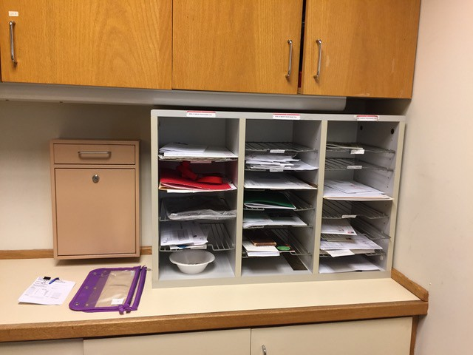
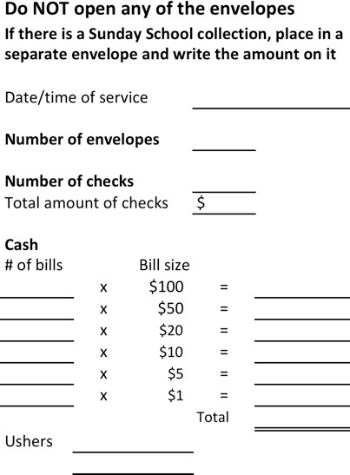
Complete the form, which should be self-explanatory. To determine the “Total amount of the checks,” feel free to write down the amount of each check on the reverse of the form and total them. Then put the form, the cash, envelopes and checks in the clear/purple envelope. Then place it in the dropbox making sure that it cannot be seen.

On church holidays and other especially busy Sundays, if there are four ushers, please follow these amended instructions:
- After the Peace, form a procession at the rear of the center aisle:
  - Two ushers with Oblations first, with cruet on right and breadbasket on left.
  - Two ushers with plates.
- Walk up as soon as the clergy pass through the gate.
  - Oblation bearing ushers proceed to altar, and proffer oblations. Exit through side doors, pick up collection plates from above radiators and collect from outside aisles.
  - Plate bearing ushers collect from center aisle.
  - Ushers reassemble in rear and when Acolyte moves to position at center of gate with large basin, move forward.
  - Place plates in basin starting with usher on the front right, followed by front left. These two step sideways, allowing back ushers to step forward and place their plates.
  - Four remain until end of doxology, then all exit through side doors, propping open doors from Education building and Parish Hall when communion follows.
  - After services, two ushers clean up, straightening kneelers and removing trash for recycling. (Put bulletins for recycling in trashcan in sacristy.)
  - Head usher and one other take offerings to office and proceed as in point 10 above.

