AT HOME
(for those who want to serve from home)
Thank you for helping to make fleece hats for Serve Sunday! There are step by step directions and fleece in the take home bags, however we also have a YouTube video you can watch and you can buy your own fleece instead of picking up a take home bag! You will need a fabric scissors. https://www.youtube.com/watch?v=CVqqOMD0QQQ = the link address to the YouTube video.

If you would like to make fleece tie blankets or crochet hats or blankets at home we will also take those and deliver them to those in need!

Please return hats/blankets to Stacy Bader by Sunday, October 24th.

Thank you!
How to Make No Sew Fleece Hats
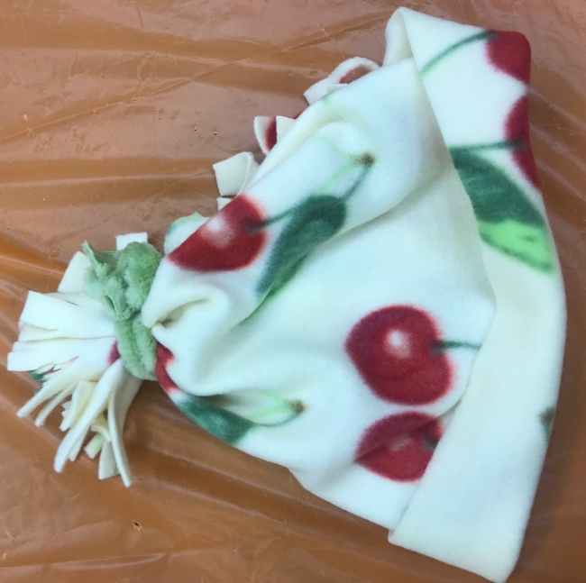

Step 1 Cut a piece of fleece roughly 14 inches high by around 18 - 24 inches (whatever fits around the recipient’s head plus 3 inches).
Step 2 Fold the fleece in half Fold is on top

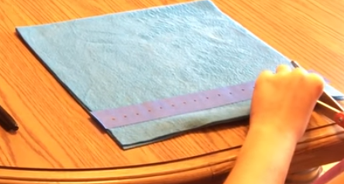

Step 3 place tape along vertical edged 2 inches up from the bottom as a guide (optional). Leave 3 inches on one side of the tape and then mark off every ¾ of an inch.
Step 4 Cut the fringe according to the marks on the tape (remember to leave 3 inches on one side). Remove the tape.

Step 5 Bring the two fringed edges together and tie small double knots between the corresponding pieces to from each edge.
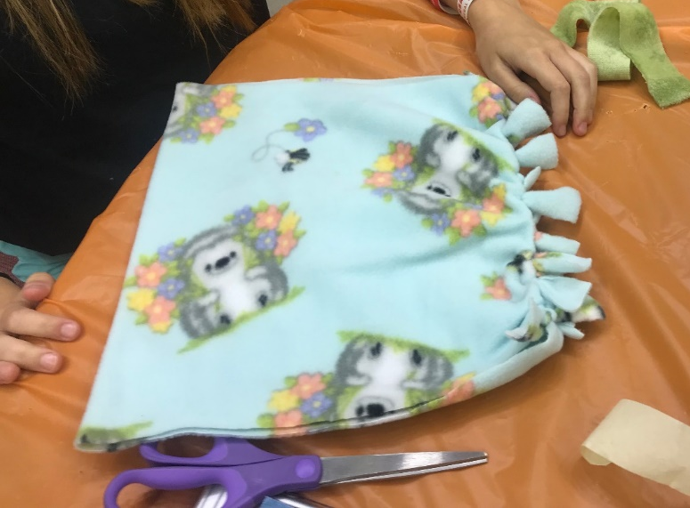

Step 6 Fold the bottom of the hat up twice for form the brim.

Step 7 Gather the top and tie it. You can make vertical cuts on the top to make a pom-pom if desired!
Step 8 Make a gift tag.
