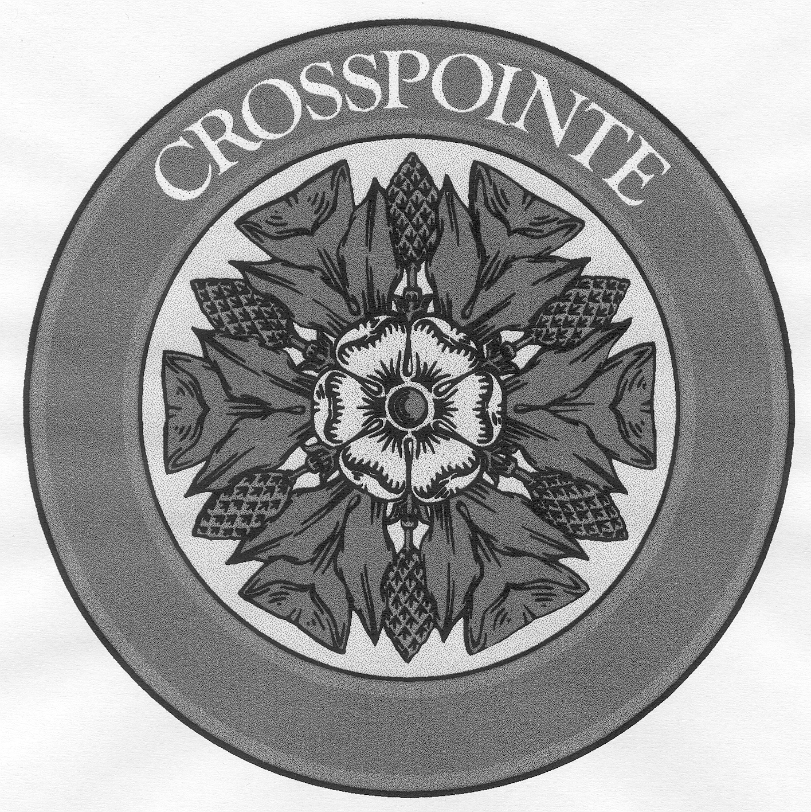

CROSSPOINTE SWIM AND RACQUET, INC.
Pool Rules and Procedures
Summer 2020
ADDENDUM – PHASE III*

POOL SEASON PHASE III

- The pools will begin operating under Phase III rules on Friday, July 3rd. Phase III will continue until a date to be determined by the Crosspointe Board of Trustees
- Free swim is permitted. Members not of the same household must maintain 10 ft of distance between one another
- Lap swim is permitted with up to three people per lane. Swimmers not of the same household may pass but must maintain 10 ft of distance to the greatest extent possible.
  - Lanes used by more than one person must be consensually agreed upon and scheduled in advance using the reservation system, otherwise one person per lane
- Diving is permitted. Divers must maintain 10 ft of distance between patrons. No recreational swimming in dive wells
- Swim Lessons are permitted during normal operations in swim lanes. Instructors may have physical contact with swimmers when necessary
- No sharable pool toys beyond household’s social distancing space (approximately 10ft)

(* In accordance with Executive Orders #67 by Governor Ralph Northam)

SWIMMING POOL ADMITTANCE

- A reservation system will be used to schedule baby pools, shallow areas, lap swim and remaining areas up to max capacity (see diagram). Members must be signed up* to enter the facility. Members will maintain social distancing of 6 ft from one another and are expected to wear face masks while outside the facility
  - Sign up instructions will be provided on the reservation system. Sessions 1, 2, and 3 are limited to ONE SESSION PER DAY. Sessions 4 and 5 have no signup restrictions. Exceptions include: 1) swim instructors, and 2) baby pool users that may sign up for an additional slot on the same day
  - * Walk-ins allowed for unreserved lap swim slots
  - * Walk-ins allowed for no shows halfway through session (up to capacity)
- Crosspointe pool membership photo identification must be shown to enter the pools, but will not be retained by pool staff
- Members will enter the main entrance and exit through the utility gate
- Crosspointe will provide hand sanitizer at pool entrances and exits
- No guests during Phase III
- No Pool Parties during Phase III
SWIMMING POOL RULES AND PROCEDURES

- Open swim sessions will be 2 hours in duration, except for the baby pools. Baby pool sessions will be one hour in duration (see Phase III schedule)
  - The baby pool will be reserved for one household at a time (max 8)
  - The shallow areas will be reserved for 2 households of up to 4 members, or one household of 5 to 8 members
  - The main pool areas and diving wells will be limited to 45 and 55 additional members for Oak Chase and Glen Eagles pools respectively
- Lap swim sessions will be 40 min in duration. There will be 3 sessions per lane during each 2-hour period
- The pool will be closed for 30 minutes every two hours for additional cleaning
- Members will be verbally screened for COVID-19 symptoms prior to entering facility
- Pool staff will wear face masks when interacting with patrons
- Members are expected to wear face masks when not in the pool
- Maintain social distancing of 10 ft between patrons not of the same household while inside the facility (except lap swim)
- Use of personal furniture is allowed and encouraged. Maintain at least 10 ft of spacing on pool deck between persons not of the same household. Crosspointe will not provide furniture for member use during Phase III
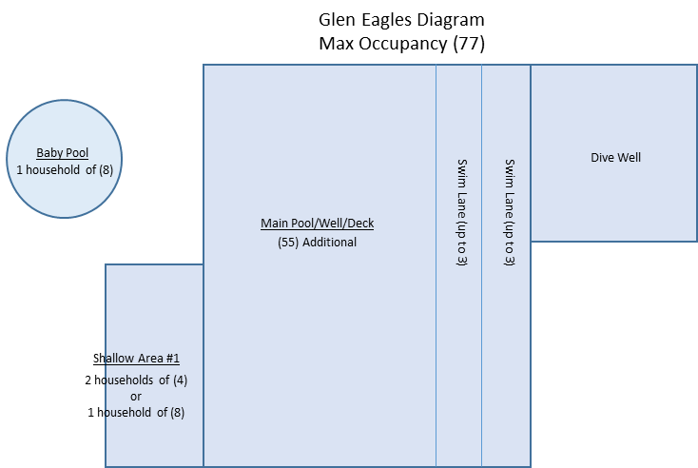
- Sunbathers (non-swimmers) must sign up for a swim slot and will be counted against the max occupancy
