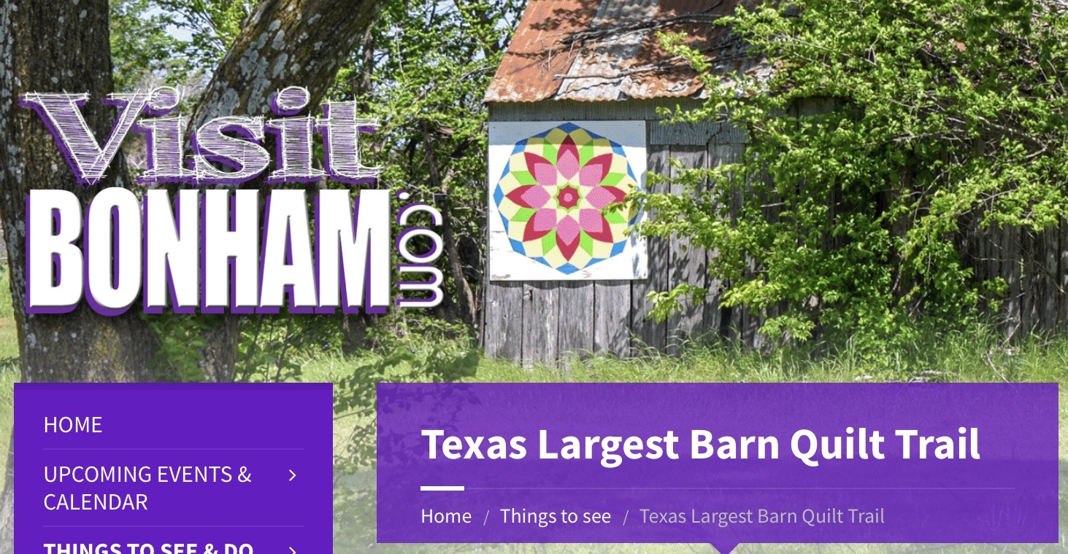

Saturday, October 23rd   
10:00 Meet at Buccee’s in McKinney  
10:45 Arrive in Bonham  
12:00 Eat Lunch  
1:00 Visit Quilt Asylum  
  
{We’ll carpool. Park in back of Buccee’s-opposite side of pumps.}

**Bonham Barn Quilt Walking Tour**

Contact Tana B. at 972-849-1916 if you need additional information. Sign up at September or October Guild Meeting.

Saturday, October 23rd   
10:00 Meet at Buccee’s in McKinney  
10:45 Arrive in Bonham  
12:00 Eat Lunch  
1:00 Visit Quilt Asylum  
  
{We’ll carpool. Park in back of Buccee’s-opposite side of pumps.}

**Bonham Barn Quilt Walking Tour**

Contact Tana B. at 972-849-1916 if you need additional information. Sign up at September or October Guild Meeting.