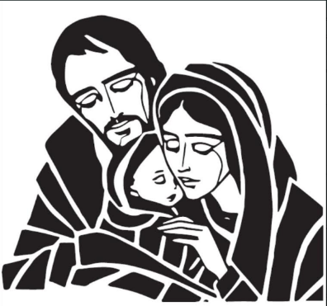

**Eat, Drink and Be Married**

Four Course Dinner and Wine Pairing

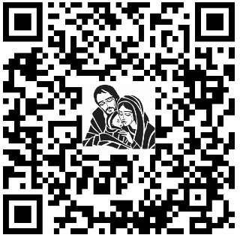

***Any Questions, Please Contact Katy & Nick Thomas @ 504-884-3456***

Please note that in the event circumstances arise that you will not be able

to attend, we are not able to refund your donation and we appreciate your support

**Registration Should be** [**completed online**](https://www.signupgenius.com/go/70A0D4DADA923ABFF2-eat)

**_________________________________________________________________________________________________**

#### **Date: Saturday, August 15, 2020**

#### **Holy Family Parish Center**

#### **Social time at your table—6:00 pm; Dinner—6:30pm**

_______________________________-

___________________________-

***You and your spouse are invited to attend an evening of fun, faith and fellowship with other couples around the parish.***

***Enjoy an evening out and leave the cooking to us.***

***Limited Seating to 23 couples***

***$60.00/couple***

***Pre-Registration Required (Deadline August 3, 2020)***