Mass-confusion to Mass Appeal:

An Explanatory Walk Through the Mass
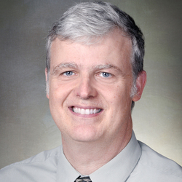  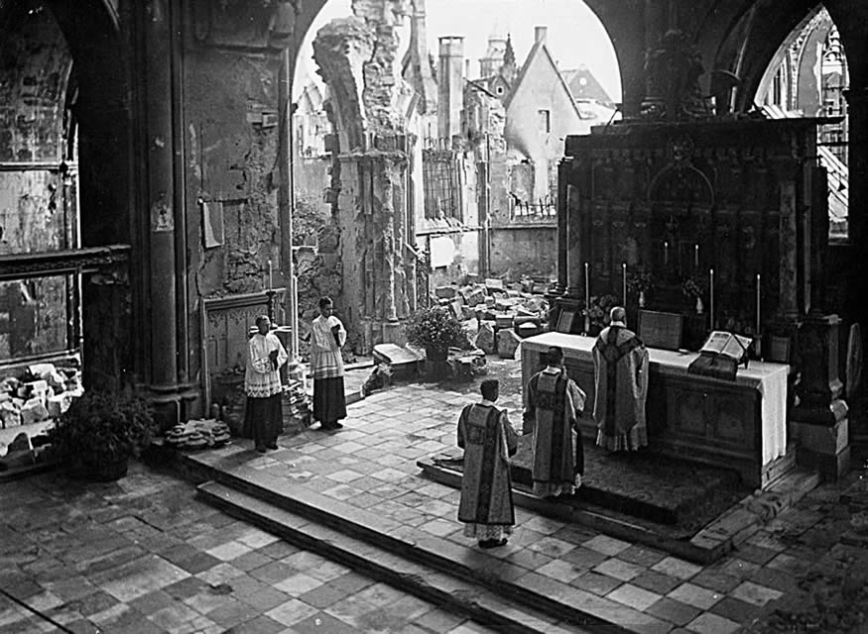  Photo courtesy of Church Pop :  St. Paul’s Cathedral in Münster, Germany (1946) |  | 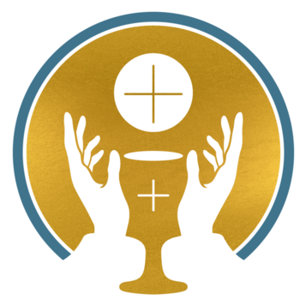  Year of the Eucharist Event!  Join Holy Family for a night of Catechesis on the Mass!  Guest Speaker:  Dr. Tom Neal, Professor at Notre Dame Seminary  Join us for an engaging and inspiring hour of faith formation. Guaranteed to enliven your participation in the mass! Adults & Families Welcome
May 2, 2021 Sunday 5:30-6:30pm Talk Held in Church with Brief Q & A session to follow
Registration is Free! RSVP by April 25th via Sign Up Genius Online @ www.holyfamilychurchluling.com
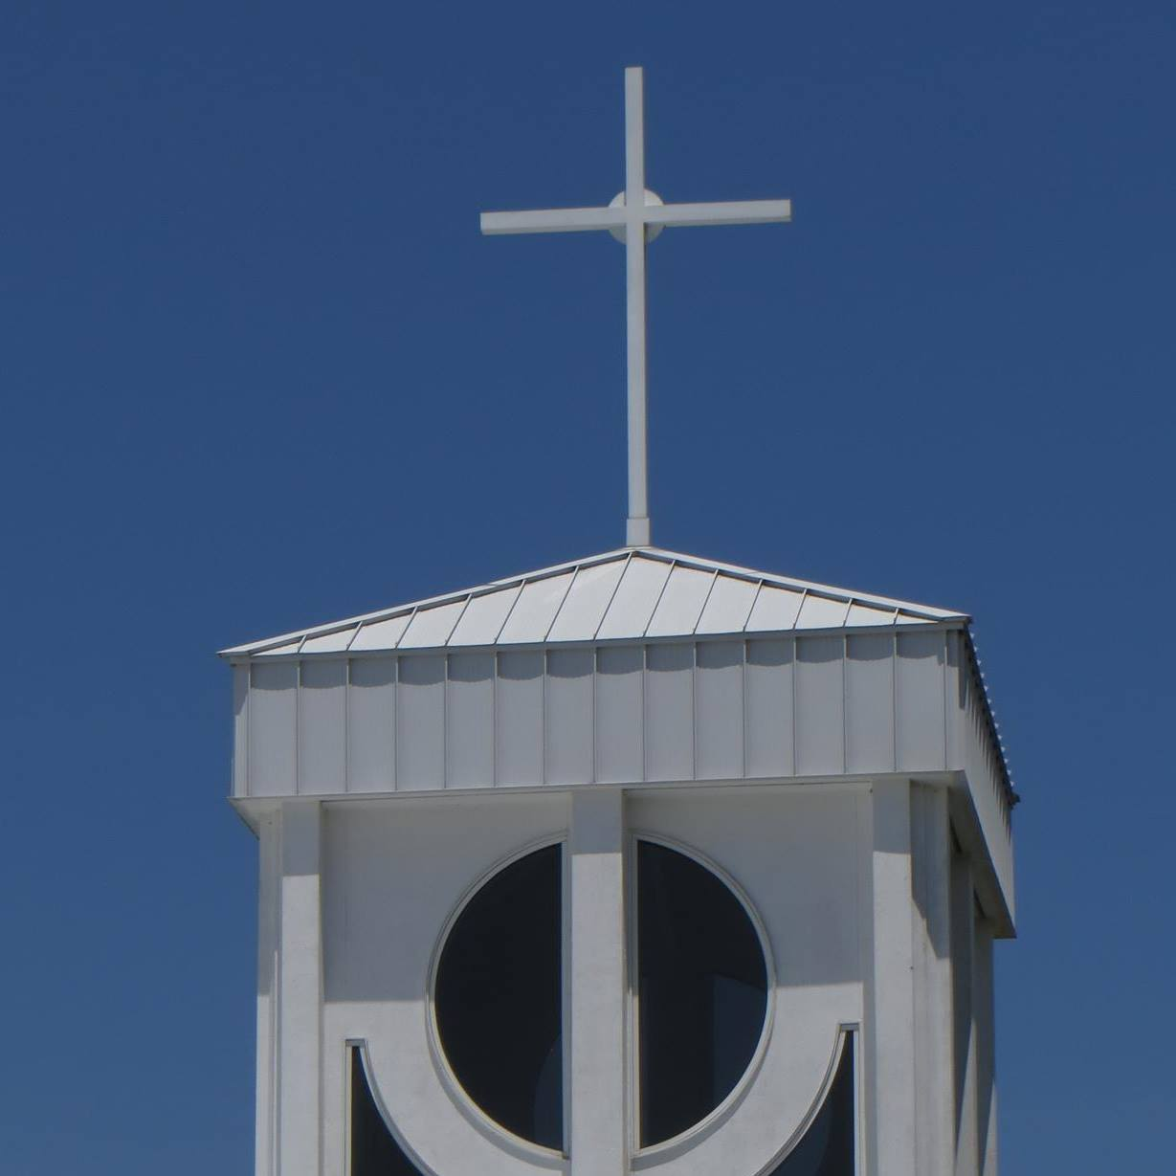 |  | Holy family Catholic Church  155 Holy Family Lane, Luling LA 70070  985785 8585 holyfamilychurchluling.com

*masks required & social distancing observed – donations accepted.

