- Go to: http://www.signupgenius.com/tabs/3377FD706A6CDEDCE8-onegs

- Find the horizontal row of tabs near the top of the screen that looks like this:

The monthly tabs are Shabbat onegs. The “Fridays” tab is all Friday evening events. The “Specials” tab is all other events.

- Find an oneg you would like to join and see if there are any slots still available:

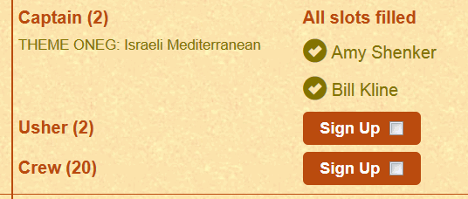

In the above example, all the captain slots are full (“All slots filled”), however there is still a “Sign Up” button for Usher and one for Crew.

- When you’re ready to sign up, click the box next to “Sign Up”:

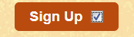

- IMPORTANT: Then click the Submit and Sign Up button at the bottom center of your screen:
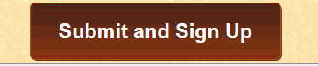

- On the next screen you will see this:
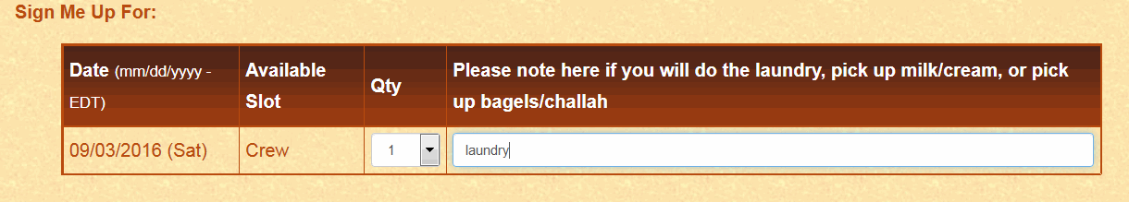

Here you have an opportunity to make a note if you are willing to do the laundry, or pick up the milk/cream, or bagels/challah.
- You do NOT need to have or create an account with SignUpGenius to sign up:
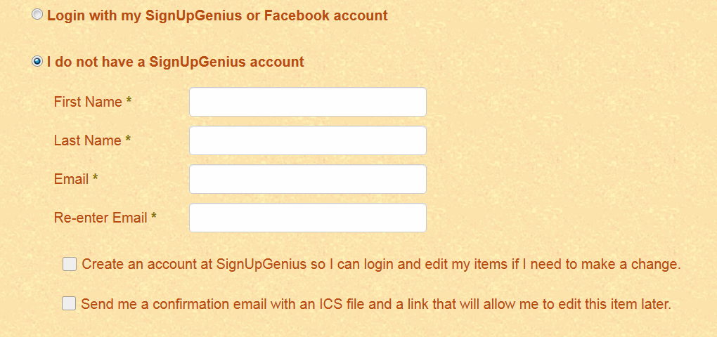
If you CHOOSE to, you can login with your existing SignUpGenius or Facebook account.
If you do not have, or do not want, an account, please fill in the four required fields (First & Last Name & Email) and do NOT check the “Create an account….” box.
If you want to create an account as you’re signing up, check the “Create an account…” box.
If you would like a confirmation email and a link to the sign up, check the “Send me a confirmation email with an ICS File…” box.
- Click SIGN UP NOW!
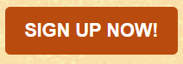

- You’re almost done! Now you’ll see a screen that looks like this:

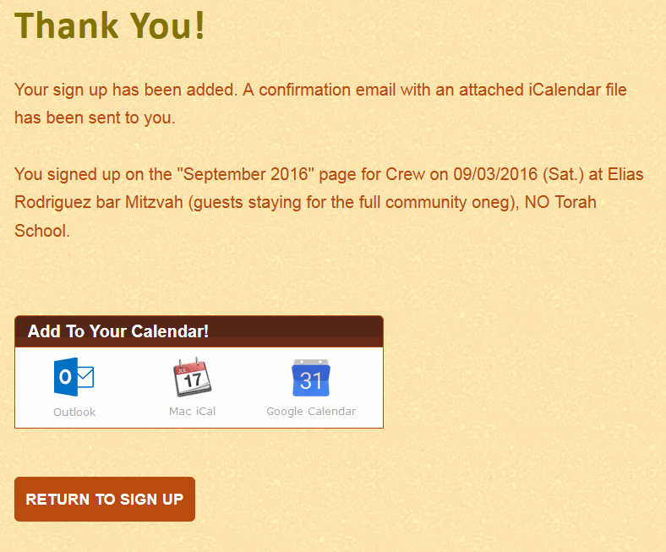
If you want to add your oneg date to your personal calendar, click on the correct calendar in the “Add To Your Calendar!” box.
Now you can close the website or click “ RETURN TO SIGN UP” to find your second date.
If you have any questions or problems, don’t hesitate to contact Debbie Bluestein, Hospitality Chair.

Thank you!

