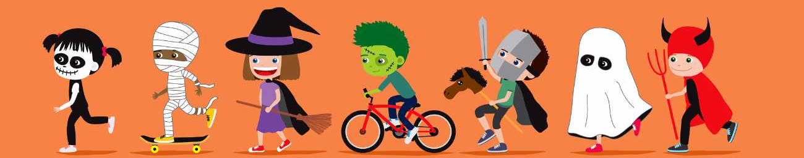

Looking for a fun and safe way to celebrate fall and Halloween? Participate in Trunk Or Treat at St. Jacob’s on Sunday, October 25, 2020 from 2pm-3:30pm. Invite family, friends and neighbors with young children to wander through our parking lot visiting cars decked out in Bible-themed decorations. Candy or trinkets will be shared with children, along with lots of smiles and fun conversation.
12-15 volunteers are needed to set up their car/truck decorated for fun and hand out the candy/toys to kids. 2-3 volunteers to direct participants and traffic in our parking areas are needed, as well. Volunteers can either call Susan Moseley or sign up via Sign Up Genius. Be sure to indicate what theme/story will be represented by your vehicle. Need some inspiration? Google ‘trunk or treat ideas’ or check out Pinterest. Susan has a list of suggestions, as well.
We will be applying for Thrivent Action Team seed money to use to purchase candy and small trinkets so that cost will not be a burden to volunteers. Participants will pre-register using Sign Up Genius to help ensure that we do not come up short with the candy!
We will do all that we can to make this a Covid-safe event by asking participants and volunteers to wear masks and maintain social distance as they move through our Trunk or Treat area. Participants will park in the lower level, walk up to the upper parking lot via the front sidewalk, make their way through the decorated vehicles in the upper parking lot, then walk back to their car via the alley on the south side of the church. This will ensure one-way foot traffic.
The Good News and Education Committees are jointly sponsoring this day of fun and hope to see a great turn out of volunteers from St. Jacob’s and lots of new faces from our community participating in the fun. There will be no cost to attend, but as a final stop before departing, a table will be set up accepting donations to Lutheran World Relief and sharing information about St. Jacob’s to those interested.
Postcard fliers are available on the table near the delivery door — stop by and pick up a few to hand out in your social circles. The more the merrier! Information can also be found on our website. Contact Susan Moseley with any questions.

