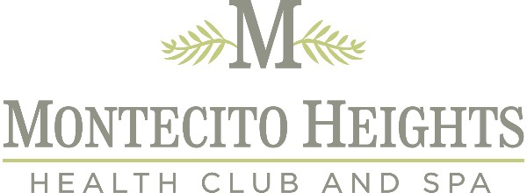

We have created the following guidelines in order to offer a safe workout for our community:
If you are feeling sick, please stay at home. You will not be admitted if you are unwell or are presenting
symptoms of any illness
• Indoor facilities will be limited to 22 users at a time.
• There will be a 15 minute clean up period between each group of members using the club.
• You must sign up for a spot in the club so we can adhere to our maximum members at one time policy
• You must bring your own towels, mat, mask, props and other equipment that is not easily cleaned.
• All charges will be put on your account. No cash transactions please
• Bathrooms are available and will be sanitized after each use
• No guests allowed at this time.
• Please view and follow all guidelines as outlined on our website at www.montecitoheights.com

___________________________________________________________________________
LEGAL DISCLAIMER - PLEASE READ. BY SIGNING UP FOR A SPOT YOU ACKNOWLEDGE YOU HAVE READ AND UNDERSTAND YOUR RISK.
The novel coronavirus (COVID-19) has been declared a worldwide pandemic by the World Health
Organization. COVID-19 is extremely contagious and is believed to spread mainly from person-to-person
contact. As a result, federal, state, and local governments and federal and state health agencies recommend
social distancing and have, in many locations, prohibited the congregation of groups of people.
Montecito Heights Health Club have put in place preventative measures to reduce the spread of COVID-19 for their programs and facilities; however, Montecito Heights Health Club cannot guarantee that you will not become infected with COVID-19. Further, attending our outdoor classes could increase your risk’s risk of contracting COVID-19.
By attending the club, you acknowledge the contagious nature of COVID-19 and voluntarily assume the
risk you may be exposed to or infected by COVID-19 by attending outdoor classes offered by Montecito Heights Health Club and that such exposure or infection may result in personal injury, illness, permanent disability, and death.
You understand that the risk of becoming exposed to or infected by COVID-19 when visiting Montecito Heights
may result from the actions, omissions, or negligence of myself and others, including, but not limited to,
Montecito Heights Health Club employees, teachers, and program participants and their families. You voluntarily agree to assume all of the foregoing risks and accept sole responsibility for any injury to myself (including, but not limited to, personal injury, disability, and death), illness, damage, loss, claim, liability, or expense, of any kind, that you may experience or incur in connection with your attendance and participation at these classes.
You hereby release, covenant not to sue, discharge, and hold harmless Montecito Heights Health Club or, their
employees, agents, and representatives, of and from all Claims, including all liabilities, claims, actions,
damages, costs, or expenses of any kind arising out of or relating thereto. You understand and agree that this
release includes any Claims based on the actions, omissions, or negligence of Montecito Heights Health Club its employees, agents, and representatives, whether a COVID-19 infection occurs before, during, or after
participation in our classes and programs.
I have read the conditions and stipulations of working out safely, and agree to adhere to the conditions and
stipulations of this waiver.

