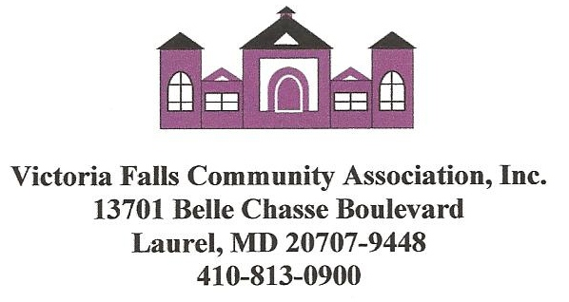
COVID-19 WAIVER, INDEMNIFICATION AND ASSUMPTION OF RISK

This Waiver, Indemnification and Assumption of Risk Agreement is in addition to any other Agreement executed by the Member concerning the use of the Victoria Falls Community Resort Club and/or its facilities, amenities, or activities.

Victoria Falls Community Association, Inc. provides its members with certain facilities, amenities, and activities through the Victoria Falls Community Resort Club (Resort Club). The facilities, amenities, and activities provided through the Resort Club include, but are not limited to, the use of the Resort Club’s facilities for fitness/exercise, indoor pool, sauna, whirlpool, outdoor pool and participation in additional programs and activities provided by Victoria Falls Community Association, Inc. to its members (all of such facilities, amenities and activities are collectively referred to in this Agreement as the Resort Club’s Services). Additionally, during the use of the Resort Club and the Resort Club’s Services, a member may come into contact with many items contained within the Resort Club. These items can include by way of example, but not by way of limitation, pool ladders, floating devices, toys, pool chairs, tables, chairs, sofas, furniture, furnishings, doors, floors, bathrooms, sinks, toilets workout equipment, other equipment, towels, toilet paper, tissues, paper towels, fixtures, appurtenances and the like and in this Agreement all such items are included within the use of the of the Resort Club and the use of the Resort Club’s Services.

Due to the recent outbreak of Coronavirus Disease known as COVID-19 (a/k/a “severe acute respiratory syndrome coronavirus 2, SARS-CoV-2)”, a member’s use of the Resort Club and the Resort Club’s Services for any reason presents a risk of transmission of COVID-19. By executing this Agreement, I acknowledge may awareness of those risks and I assume all of the risks associated with contracting COVID-19 during my use of the Resort Club and the Resort Club’s Services.

Further, as a Victoria Falls Community Association, Inc. member I hereby acknowledge that my use of the Resort Club, and the Resort Club’s Services, is conditioned upon my assumption of the risks associated with COVID-19 virus. Therefore, I hereby acknowledge that I am aware of the recent outbreak of Coronavirus Disease known as COVID-19 (a/k/a “severe acute respiratory syndrome coronavirus 2, SARS-CoV-2)” and that COVID-19 is a virus that may mutate and/or evolve over time. I am aware that COVID-19 is a highly contagious new virus that can spread easily by simply being near any infected person or from contact with surfaces that the infected person has been near. I am also aware that COVID-19 infections can cause severe illness, and, in some cases, COVID-19 can cause death or permanent disability. Moreover, I am also aware that the use of the Resort Club and the Resort Club’s Services creates a risk that I may become infected with COVID-19 and that severe illness, death or permanent injury could result from that infection. Moreover, I further acknowledge I am willing to assume all risks associated with contracting the COVID-19 virus or any mutation or variation of the COVID-19 virus that may occur from my use of the Resort Club and the Resort Club’s Services. I further acknowledge that I voluntarily agree to abide by all of the rules related to the Resort Club and the Resort Club’s Services including, but not limited to, any rules related to the prevention of the spread of the COVID-19 virus or any mutation or variation of COVID-19.

Further, I am familiar with the Centers for Disease Control and Prevention (“CDC”) guidelines regarding COVID-19. I acknowledge and understand that that the circumstances regarding COVID-19 are changing from day to day and that, accordingly, the CDC guidelines are regularly modified and updated and I accept full responsibility for: (1) familiarizing myself with the most recent updates; and (2) abiding by the CDC guidelines.

In consideration of having the opportunity to use the Resort Club and the Resort Club’s Services and in acknowledging that I am aware of and willing to assume the risks associated with such use, I hereby, waive, release and forever discharge Victoria Falls Community Association, Inc., FirstService Residential, American Pools LLC, Planned Building Services, and/or their respective officers, directors, shareholders, successors, assigns, attorneys, site manager, property manager, employees, and/or agents, subsidiaries, and affiliates from any and all claims, damages, and causes of action of any kind or nature arising from my use of the Resort Club and the Resort Club’s Services which are in any way related, directly or indirectly, to contracting the COVID-19 virus or any mutation or variation of the COVID-19 virus that may occur from my use of the Resort Club and the Resort Club’s Services which I may have or that hereafter may accrue including, but not limited to, any such claims or causes of action related in any way to contracting the COVID-19 virus or any mutation or variation of the COVID-19 virus caused in whole or in part by the negligence, whether active or passive, of Victoria Falls Community Association, Inc., FirstService Residential, American Pools LLC, Planned Building Services, and/or their respective officers, directors, shareholders, successors, assigns, attorneys, site manager, property manager, employees, and/or agents subsidiaries and affiliates. I further agree to indemnify, defend and hold harmless the Victoria Falls Community Association, Inc., FirstService Residential, American Pools LLC, Planned Building Services, and/or their respective officers, directors, shareholders, successors, assigns, attorneys, site manager, property manager, employees, and/or agents subsidiaries and affiliates, from any claims or causes of action of any kind arising from my use of the Resort Club and the Resort Club’s Services that are related in any way to contracting the COVID-19 virus or any mutation or variation of the COVID-19 virus.

By placing my signature below, I acknowledge and agree that I have read this agreement, understood all of the terms and conditions contained herein, and that this agreement will be in full force and effect during each time I use the Resort Club and the Resort Club’s Services for any reason.

IN WITNESS WHEREOF, I have signed this COVID-19 WAIVER, INDEMNIFICATION

AND ASSUMPTION OF RISK under seal on this

_____________________________ day of _______________________, 2021.

PRINT NAME: ______________________________________________________

SIGNATURE: ______________________________________________________

