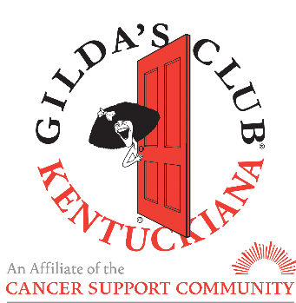

Preparing for Your Meal

We are often asked what members like to eat, or what some good ideas are for serving large groups. Below you will find a list of some meal ideas that our members always rave about. A good rule of thumb is to offer fresh, healthy foods, as nutrition is always a top concern for folks affected by cancer. Any time meal hosts avoid highly processed, sugary or fattening foods, members definitely notice and appreciate it. For example, if you decide to serve a hot dog bar, something that traditionally might not be considered “healthy,” you could might consider offering all-beef or kosher hot dogs as well as veggie or turkey dogs. Easy peasy!

The list below is by no means all-inclusive, but should give you some ideas. Please do not feel restricted to this list. Feel free to be creative! Don’t worry about serving something members may have had recently – members are simply thankful to you for being here. We do have a grill that can be used in the warmer months (just be sure to give us a heads up when you plan to use it, so we can make sure it has enough propane). We do ask that you include at least one vegetarian option for our non-meat eating folks. Our vegetarian members are always so thankful when something has been planned especially for them (as opposed to having to eat everything but the main course).

Portion Sizes: this website has some helpful tips for calculating how much food you’ll need to feed a large group: https://www.leaf.tv/articles/how-to-calculate-food-for-large-groups/

You may also order from a restaurant and simply set up and serve the food. Some restaurants we’ve had success with in the past are: Fazoli’s, Mark’s Feed Store, Panera, and Q’doba. Our address for delivery is 2400 Grinstead Drive, Louisville KY 40204

Meal Ideas:
- Salad Bar (always a big hit!)
  - Spring mix/spinach/power greens, veggies of any kind, croutons, cheeses, protein of some kind (meat or veggies), nuts, fruits
- Baked Potato Bar with toppings
  - Cheeses, sour cream, chili topping, green onions, bacon, salsa, steamed broccoli
- Taco or Nacho Bar
  - Meat or veggie protein, peppers and onions, salsa, cheese, sour cream, guacamole, lettuce
- Pasta Bar – build your own pasta bowl
  - Different pasta options, sautéed veggies, meat and veggie sauce options
- Breakfast for Dinner
  - Oatmeal, egg bakes, waffles, fresh fruit
- Summer Picnic
  - Burgers and dogs with all the fixins’ and sides (you can even use our grill!)
- Chili or Soup
  - Meat and veggie chilis, any kind of homemade soup with salad and bread

