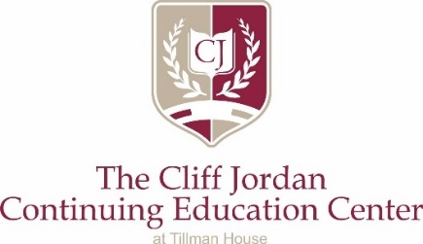

GREETERS

“God has given each of you a gift from his great variety of spiritual gifts. Use them well to serve one another.” 1 Peter 4:10

Studies suggest first impressions are everything. As a Greeter at
The Cliff Jordan Continuing Education Center you will be our students and guests first impression. Greeters are critical to our success and because of COVID-19 your job is even more important.

WHERE?

There will be a table set up at the entrance to the Education Center. (At the double glass doors on the far side of the building.). All materials are stored in the downstairs classroom A105. When you enter the room, you’ll see a credenza on the right side. The plastic container includes the necessary forms, thermometer, etc. Also, you will find cookies and bottle water or snacks.

WHAT?

- Blank sign in forms. Please make sure every student signs in. CHECK TO MAKE SURE THE FORMS ARE LEGIBLE.
- COVID-19 Waiver forms
- Tillman House Waiver forms
- Resource information, is in the brown expandable file also on the credenza, packets should a guest inquire (food assistance, rent assistance, utilities, etc.
- Pens/Paper
- Contact numbers for emergencies
- Hand Sanitizer
- Thermometer
- Refreshments
- Mask

HOW?

- Welcome students as they enter and confirm which class they are attending. MASK ARE REQUIRED AT ALL TIMES.
- Give student both waiver forms: Tillman House and COVID 19 EVEN IF THEY COMPLETED THEM IN 2020. The student can complete the Tillman form in the classroom and give to the instructor.
- Review COVID waiver specific to the section they are agreeing to when they sign the waiver i.e., they nor anyone in their household not have symptoms of COVID 19, no one in their household has been diagnosed OR exposed to anyone with COVID 19, they have not traveled outside the country in the last 30 days.
- Have the student complete and sign the COVID waiver BEFORE going to class.
- Take the person’s temperature (point the thermometer at their forehead and write in the upper righthand corner of the COVID 19 waiver form
- Give student Tillman House waiver form and tell them to complete it when they get to class. The instructors will collect the completed Tillman House waiver.
- Offer bottled water and cookies or snacks as referenced above
- Give student Education Center flyer listing other classes.

WHY?

Pursuing hospitality, we ask that you remain until the students leave after their class. As they leave, thank them for coming, that we look forward to seeing them again and again offer refreshments.

Return items to A105 so that they are available for the next class. If you greeter assignment is at night, please lock the door when you leave. PLEASE return key to lock box and turn dial so that it is no longer set to the “open” combination.

Each individual volunteer opportunity for greeters will require, on average, a time commitment of 2 hours.

Still have questions?
Donna Jordan 770-241-4556

Rev. 2 01/02/2021

