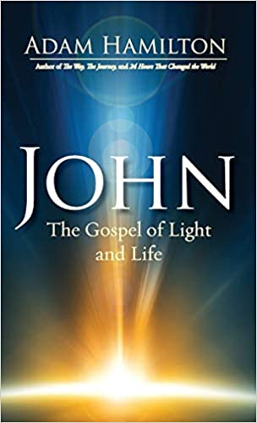
A limited number of books are available at the Cliff Jordan Continuing Education Center or you can purchase the book for this class on Amazon.
Amazon:
https://www.amazon.com/John-Gospel-Light-Life/dp/1501805339/ref=sr_1_1?dchild=1&keywords=adam+hamilton+john&qid=1612981536&sr=8-1

https://www.amazon.com/John-Gospel-Light-Life/dp/1501805339/ref=sr_1_1?dchild=1&keywords=adam+hamilton+john&qid=1612981536&sr=8-1

