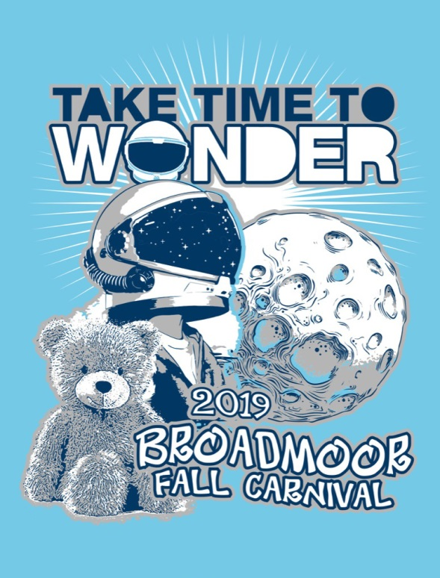
2019 BROADMOOR

FALL CARNIVAL T-SHIRTS

Celebrate our fall carnival year-round by ordering your child a carnival t-shirt by Friday, September 20!

This year there are two convenient ordering options:
- Online at Sign-Up Genius is as easy as 1,2,3
Go to:
https://signupgenius.com/go/70A0D44AAAE2CA3F58-carnival1
  - Either Log In or Create a Sign Up
  - Place t-shirt order
- Paper Form submitted by the student
  - Fill out form below
  - Submit form and exact cash or check made payable to Broadmoor Elementary

All students will be able to wear the 2019 Carnival t-shirt on Mondays in the place of a regular uniform shirt.

Contact Mona Wilkinson at Monawil83@yahoo.com or Genny Jock at Genny.Jock@gmail.com with any questions. Thank you for your support!

FILL OUT THE FORM BELOW TO ORDER A 2019 CARNIVAL T-SHIRT
Short Sleeve | Quantity |  | Cost Per Shirt |  | Total Cost Per Size
Youth XS (2-4) |  | X | $15 | = | $
Youth S (6-8) |  | X | $15 | = | $
Youth M (10-12) |  | X | $15 | = | $
Youth L (14-16) |  | X | $15 | = | $
Adult Small |  | X | $15 | = | $
Adult Medium |  | X | $15 | = | $
Adult Large |  | X | $15 | = | $
Adult XL (add $2) |  | X | $17 | = | $
Adult XXL (add $2) |  | X | $17 | = | $
Total Amount Due $______________

STUDENT’S NAME _______________________________PHONE _______________ TEACHER/GRADE________________

T-SHIRT COMMITTEE ONLY (RECEIPT SENT FOR FULFILLED ORDERS)
Short Sleeve | Quantity |  | Cost Per Shirt |  | Total Cost Per Size
Youth XS (2-4) |  | X | $15 | = | $
Youth S (6-8) |  | X | $15 | = | $
Youth M (10-12) |  | X | $15 | = | $
Youth L (14-16) |  | X | $15 | = | $
Adult Small |  | X | $15 | = | $
Adult Medium |  | X | $15 | = | $
AAdult Large |  | X | $15 | = | $
Adult XL (add $2) |  | X | $17 | = | $
Adult XXL (add $2) |  | X | $17 | = | $
Total Amount Due $______________

STUDENT’S NAME ________________________________PHONE _______________ TEACHER/GRADE_______________

